High Level Design – Training Management System

**Team: Euphoria**

**Version:** 1.0

**Date:** April 20, 2022

Table of Contents

**1. System Architecture** **1**

**2. Interactions** **2**

**3. Non-Functional Requirements** **2**

**4. Data Model** **4**

**5. Database Diagram** **5**

**6. Services and Dependencies** **6**

**1.System Architecture:**

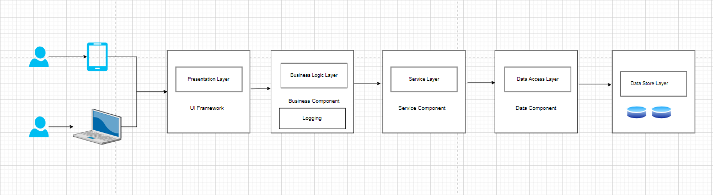

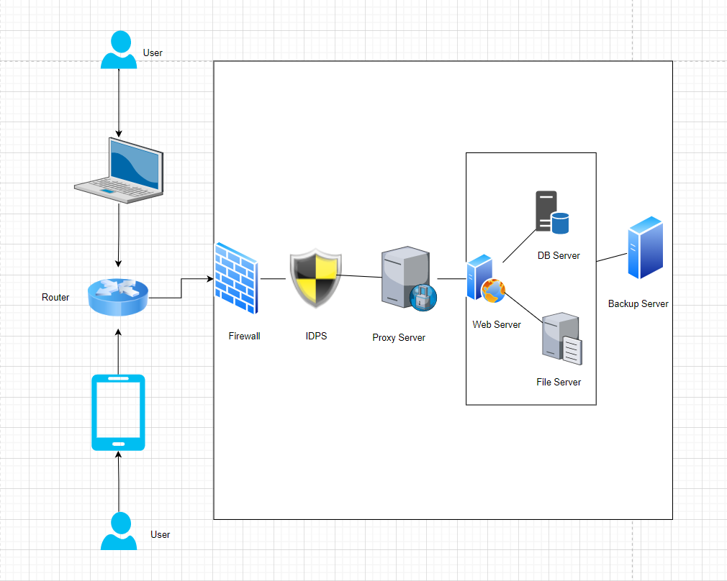

**2.Interactions:**

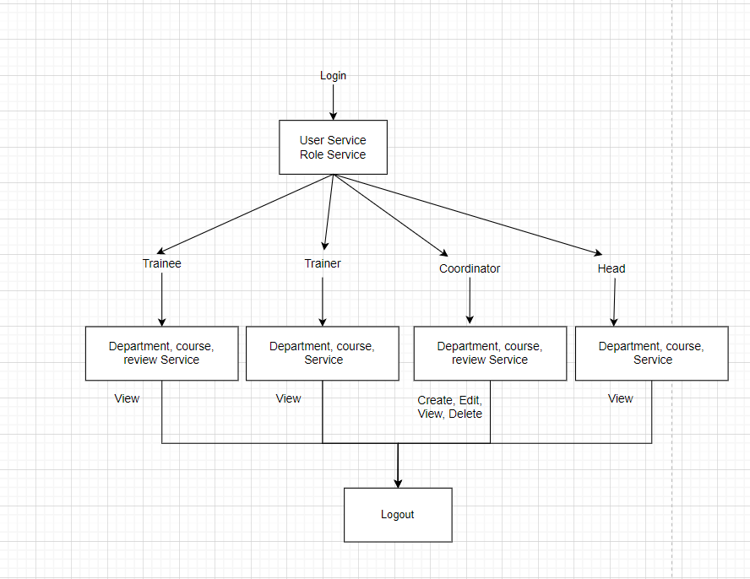

**3.Non-Functional Requirements:**

**Responsiveness:**

Responsiveness means the ability of a software system to work in a different environment if the underlying dependent framework stays the same.

**Usability:**

Usability requirement specifies how easy the TMS must be to use. It measures the usability of the system being developed. It should be convenient to use and user-friendly.

**Maintainability:**

Maintainability of a software system is the ease with which the system can be maintained. In addition to a variety of technical approaches to ensuring maintainability, such as high cohesion / loose coupling, SOLID principles, using standard API formats and clear document interfaces, it’s important to track code, exception and architecture metrics so that you can see where issues may be occurring and improvements needed

**Scalability:**

TMS has ability to appropriately handle increasing (and decreasing) workloads. It means that the system must be able to accommodate larger volumes of data over time, and also includes the elasticity, which is the ability to scale up and down quickly, as needed.

## **Security:**

In our TMS we built a data security system, where only the user who has the valid login credential can login and access the relevant data to him and not others data.security includes confidentiality and authentication to ensure this information is protected by default.

## **Feedback Requirements:**

In our TMS, we collect feedback from the trainer as well as trainee. This will be used to enhance the further performance.

**4.Data Model:**

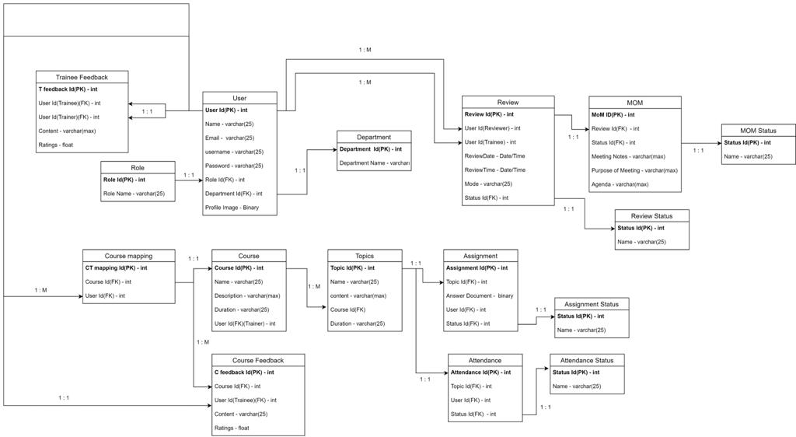

**5.Database Diagram:**

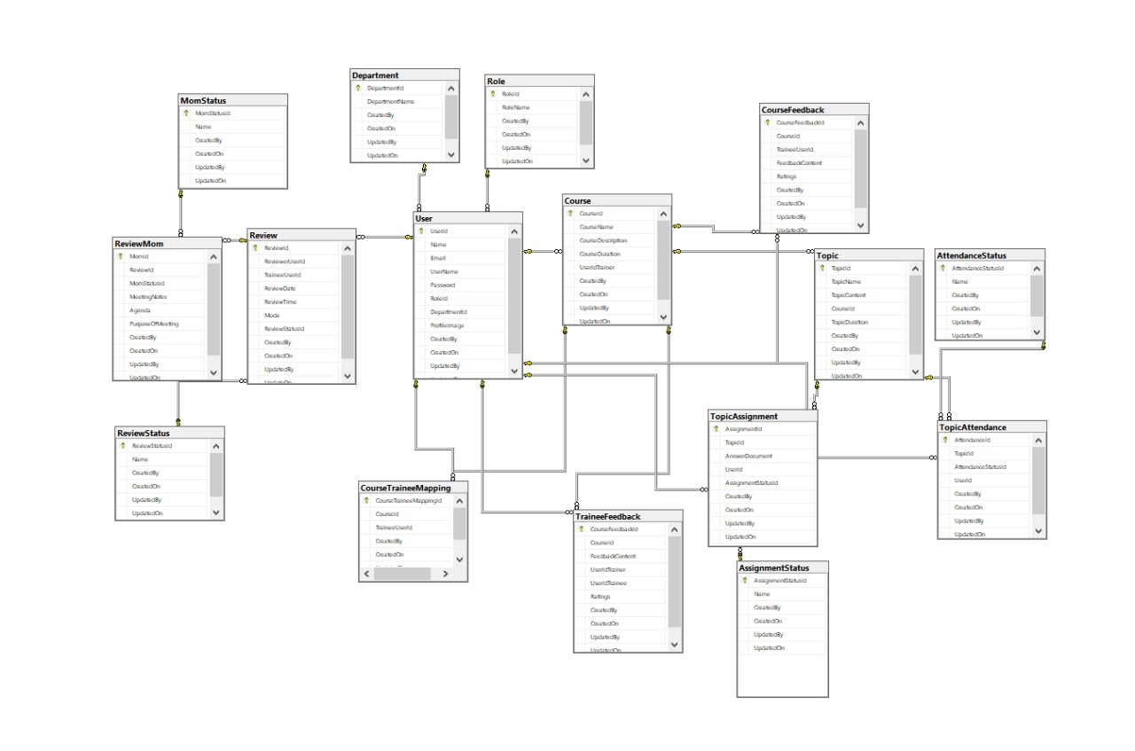

**6.Services and Dependencies:**

